First Steps Chalgrove and Watlington Family Hub
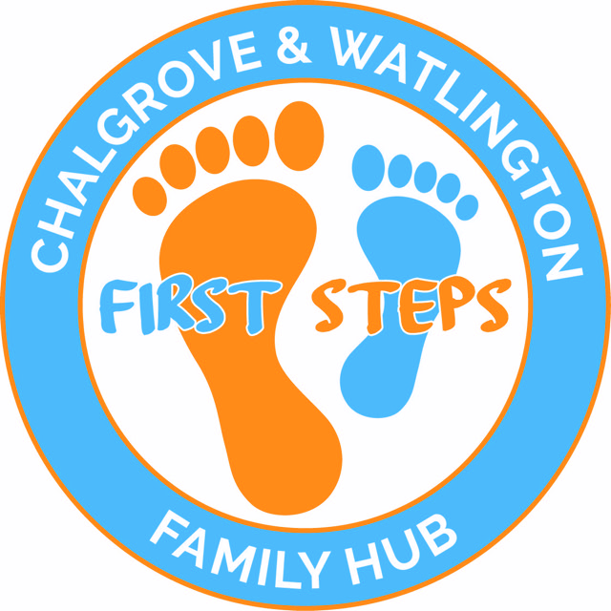

Parent/Carer’s Information
Parent 1 | Parent 2
Name

Address

Date of birth

Mobile number

Email

Do you have a disability?

Are you a lone parent?

Are you in education or training?

Do you live in a workless household family?
Health visitor or medical practice details
Do you have any other children over 5 years?
Emergency Contact Details ie Grandparent or Friend
Children’s Information
Child 1 | Child 2
Full name
Date of birth
Gender
Child's first language
Does the child have a disability?
Ethnic background
Please add any other information
you feel is important.
Eg. Allergies or essential medical details
Data Protection
Please ensure you have read our Data Privacy Notice. It is displayed in the Family Hub and is available on our website. By signing this form you are opting in and giving permission to First Steps Family Hubs to store and process this information in accordance with the General Data Protection Regulation which came into force on the 25th May 2018. It will be processed only for the use by First Steps Family Hubs Staff and Committee Members to monitor use of the services by families, to keep in touch, for the safety and wellbeing of users in the sessions and produce anonymised data for grant applications. Information will be kept securely and not shared with any organisations unless there are safeguarding concerns about you or a family member. Once you are no longer in contact with the Family Hubs, or you request to be removed, all the data we hold on you will be destroyed. Information held will be reviewed on an annual basis.

Signed/Date:

Photographs
I give permission for my child and myself to be photographed during the sessions organised by the Chalgrove and Watlington Family Hub. I understand that these photographs may be used for display and publicity purposes. I will be made aware when any photographs are being taken.
Signed/Date:

Covid 19 Vaccinations:

Date of first vaccine:

Date of second vaccine:

Would you like to receive our newsletter via email? |  | Yes ( ) No ( )

